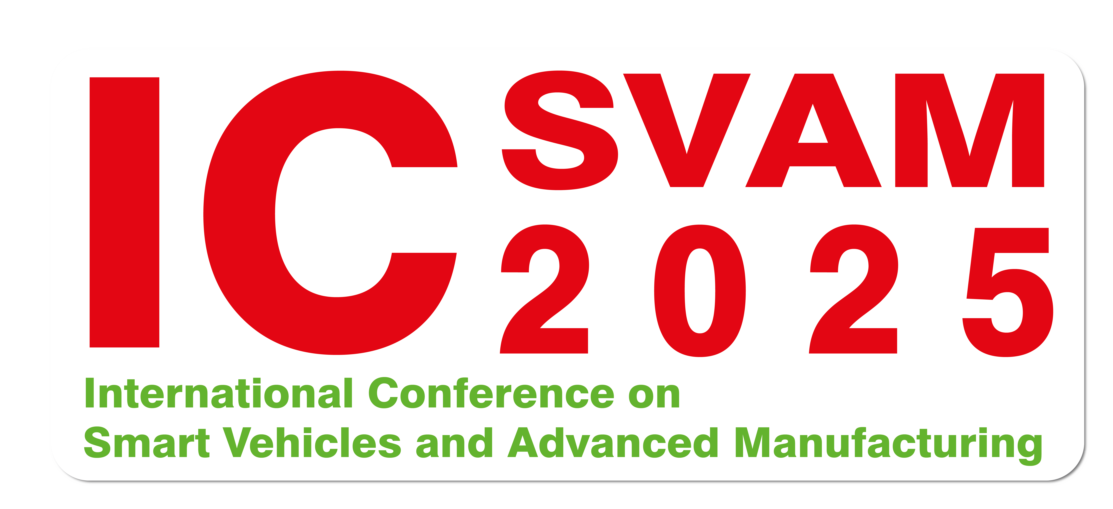 | THE INTERNATIONAL CONFERENCE ON SMART VEHICLES AND ADVANCED MANUFACTURING  Email: khoacokhidongluc@nctu.edu.vn  Website: https://nctu.edu.vn/events/icsvam2025-conference/

ARTICLE TITLE
A Nguyen Van¹, B Tran Dinh²
¹Agency A
²Agency B
Abstract:
The abstract should clearly state the "research problem", "direction/solution" and "results achieved". The English title is presented in Times New Roman, size 14, capitalized, bold, and centered, with line spacing of 6pt above and 0pt below. The author’s name is in Times New Roman, size 12, bold, and centered, with line spacing of 12pt above and 0pt below. The author’s affiliation is in Times New Roman, size 12, centered, with line spacing of 3pt above and 0pt below. The English abstract not exceeding 200 words. It provides a concise summary of the study, with a total length not exceeding one A4 page. The abstract text is in Times New Roman, size 12, with line spacing of 6pt above and 0pt below. The term “Abstract” is italicized and bold. Page margins are set as follows: top 2.5 cm, bottom 2.5 cm, left 3 cm, and right 2.5 cm.
Keywords: Keyword1, Keyword2, (no more than 5 keywords)

